30/07/2025, 01:17

Creating accessible PDFs from LibreOffice Writer | Make Things Accessible



Search for Guides or Tags, by keyword

Creating accessible PDFs

from LibreOffice Writer

By: Steve Wilkinson

Posted: May 17, 2024

Tagged with:

LibreOffice

Writer

PDF

Documents

Table of contents

https://www.makethingsaccessible.com/guides/creating-accessible-pdfs-from-libreoffice-writer/

1/36

30/07/2025, 01:17

Creating accessible PDFs from LibreOffice Writer | Make Things Accessible

**Before starting**

Make sure that your version of LibreOffice is Version 7 or above – check by going Help

-> About LibreOffice, or if not installed, download LibreOffice (external website)

Older versions may require the tool to be turned on as an Advanced option (“Enable

experimental features (may be unstable)”) but it is inbuilt in more recent versions

Make sure that Adobe Acrobat Pro is up-to-date

Download PAC 2024 (external website)

**Demo file**

An example file, LibreOffice-un-accessible.odt (ODT 164KB), has been created which

has issues that need to be corrected.

**Making documents correctly**

**Title, Author etc.**

While Title is the only field that is required in an accessible PDF, it is worth adding

Keywords for SEO, adding the Subject, and a generic Contributor and a Publisher. If you

do not wish the name of the real author all over the internet, replace them with

organisation name.

**Headings**

Use the headings built into LibreOffice Writer

The page content should be outlined in the headings, which helps AT users

comprehend the page layout and navigate to interesting content:

Main heading = Heading 1

Sub-headings = Heading 2

Sub-sub-headings = Heading 3 etc.

https://www.makethingsaccessible.com/guides/creating-accessible-pdfs-from-libreoffice-writer/

2/36

30/07/2025, 01:17

Creating accessible PDFs from LibreOffice Writer | Make Things Accessible

**Lists**

Use the inbuilt document list controls within LibreOffice Writer to add ordered lists

(numbers) and unordered lists (bullet points)

AT users can understand lists created as lists because of the way content is organised

Lists will communicate helpful information such as:

How many items the list has

Where the list starts and where the list finishes

Which list item the user is on

**Hyperlinks**

The destination of links should be communicated accurately and clearly

Use URL shortening services such as Bitly (external website) or TinyURL (external

website) if the document is to be printed, if not, make sure the link text is meaningful

(link shorteners can be viewed as a security risk as the destination cannot be seen

unless the link has been clicked!)

Screen readers will generally provide a list of links so make sure the link text is

meaningful

Do not use “click here” or “More information” for all the link text because it will not be

possible to distinguish the links from each other

**Alternative text for images (alt text)**

Alt text is used to convey the content of the image to those who can’t see it

Screen readers will declare the image, then read the alt text

Images that have no informative content and are purely decorative do not require alt

text, but may require markup so that Assistive Technology understands that they

should be ignored

Remember to avoid punctuation as it is voiced

MakeThingsAccessible has a guide to creating meaningful alternative text

**Image use**

https://www.makethingsaccessible.com/guides/creating-accessible-pdfs-from-libreoffice-writer/

3/36

30/07/2025, 01:17

Creating accessible PDFs from LibreOffice Writer | Make Things Accessible

Only use images that support the text of the document

Try avoiding the use of an image instead of text

Make sure images have alt text unless they are decorative

**Language**

Leading screen reader software is multilingual.

**Language of document**

The language of the document must be set so that screen readers will read the

document using the correct language profile.

**Language of part of document**

Content within the document written in a different language to the document’s default

language must be identified.

**Tables**

Do not use tables to control layout

Use tables to communicate relationships between data

Make sure headers are identified

Try to keep the table simple

If the table is complicated, can it be split into multiple tables or into lists?

**Other things to take into**

**account for accessibility**

**Plain English**

Make sure sentences are short and concise, around 20-25 words

https://www.makethingsaccessible.com/guides/creating-accessible-pdfs-from-libreoffice-writer/

4/36

30/07/2025, 01:17

Creating accessible PDFs from LibreOffice Writer | Make Things Accessible

Make sure words are kept simple

Use common words. Complicated longer words (8 or 9 letters) will cause readers to

skip shorter words (3,4, or 5 letters) that follow

Use an Active voice rather than a Passive voice

Where possible, use words containing one to two syllables

Aim the language used at the level of a 9 year old as recommended by GOV.UK

(external website) – remember in the UK, 7.1 million adults read at, or below, the level

of an average 9 year old. WCAG 3.15 Reading Level (AAA) (external website)

recommends providing a simplified version of the text if it requires a reading age of

more than 12 years old

Use contractions, words made up of two short words joined with an apostrophe such

as I’ve, can’t etc.

Do not use double negatives

Explain the unusual, to help give full information

**Why use it?**

The use of Plain English helps all users, including those who’s English is not their main

language, and those who have cognitive impairment

If the content is easy to read, it will be easy to understand when converted into

alternative formats such as braille, or being read aloud by a screen reader

Clear content converts more easily into British Sign Language

**Further help**

Free services, guides, and resources to help are available from the Plain English

Campaign (external website)

Measure the readability of the text using Hemingway Editor (external website)

**Font**

Use a font that is “sans-serif” and clear such as Arial, Helvetica, or Verdana

Minimum font-size of 12

For continuous text, avoid using capitals - letters in lowercase are read more easily

Do not use underlining and italics because they could make text harder to read

Bold and large font can be helpful when emphasising and highlighting text

https://www.makethingsaccessible.com/guides/creating-accessible-pdfs-from-libreoffice-writer/

5/36

30/07/2025, 01:17

Creating accessible PDFs from LibreOffice Writer | Make Things Accessible

Make sure that text is justified to the left, as this helps to make sure there is an even

gap between words, and enables the start and end of each line to be found easily

**Colour**

Do NOT use colour by itself to show meaning

Make sure that there is adequate contrast between background and text – use TPGi’s

Colour Contrast Analyzer (CCA) (external website) to check contrast

**LibreOffice Accessibility Check**

Accessibility Check (external website) tests LibreOffice Writer documents for the

following potential accessibility issues:

Check that the document title is set

Check that the document language is set, or that all styles that are in use, have the

language set

Check all images, graphics, OLE objects for the alt (or title in some objects) text

Check that tables do not include split or merged cells, which could be disorienting for

users with visual impairments

Check for fake/manual numbering (not using integrated numbering). For example

writing "1." "2." "3." at the beginning of the paragraphs

Check that hyperlink text is not a hyperlink itself - hyperlink should be described

Check for the contrast between text and the background. The algorithm is described

in the WCAG specification

Check for blinking text, which can be problematic for people with cognitive disabilities

or photosensitive epilepsy

Check for footnotes and endnotes, which should be avoided

Check for heading order. Order of the headings must increase incrementally with no

skips (for example Heading 1 to Heading 3, skipping Heading 2)

Check, if text conveys additional meaning with (direct) formatting

https://www.makethingsaccessible.com/guides/creating-accessible-pdfs-from-libreoffice-writer/

6/36

30/07/2025, 01:17

Creating accessible PDFs from LibreOffice Writer | Make Things Accessible

**Running the Accessibility**

**Check**

Tools menu -> Accessibility Check… (or Alt + 8)

The errors reported are:

Document: Document default language is not set

Document: Document title not set

Missing alternative or description text: 3 images

Table: “Table1” contains merges or splits

Formatting: The text formatting conveys additional meaning (58)

Formatting: Avoid newlines to create space (3)

Formatting: Avoid using empty table cells for formatting

Hyperlink: Hyperlink text is the same as the link address

Numbering: Simulated numbering “1. 2….”

Other: Avoid footnotes (2)

Other: Avoid endnotes

Other: Outline levels should start with level 1, instead of level 2

Other: Outline levels of headings not in sequential order

Other: A heading with outline level 4 must not follow a heading with outline level 2

Other: Text contrast is too low

Other Blinking text

**Fixing the issues**

Note: sometimes you may need to save and close and reopen the document to get the

Accessibility Check to recognise that you have fixed the error.

**Language**

**Language of document**

Click on the

https://www.makethingsaccessible.com/guides/creating-accessible-pdfs-from-libreoffice-writer/

7/36

30/07/2025, 01:17

Creating accessible PDFs from LibreOffice Writer | Make Things Accessible



by “Document default language is not set” or Tools menu -> Options, Languages and

Locales -> General

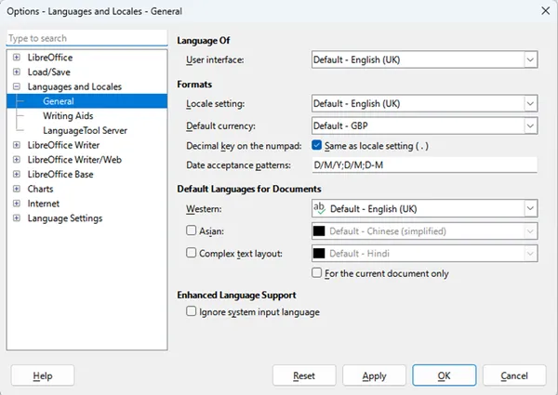

Tools -> Options, Language -> For All Text -> language required

**Language of part of document**

Select text that is of a different language to the main document

Tools -> Language -> For Selection (or For Paragraph, as applicable) -> language

required

**Title**

The error reported is “Document title not set” as this is a required field for accessibility.

Click on the

https://www.makethingsaccessible.com/guides/creating-accessible-pdfs-from-libreoffice-writer/

8/36

30/07/2025, 01:17

Creating accessible PDFs from LibreOffice Writer | Make Things Accessible



by “Document title is not set”

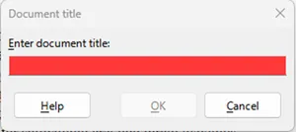

Go to File menu -> Properties… and then Description tab

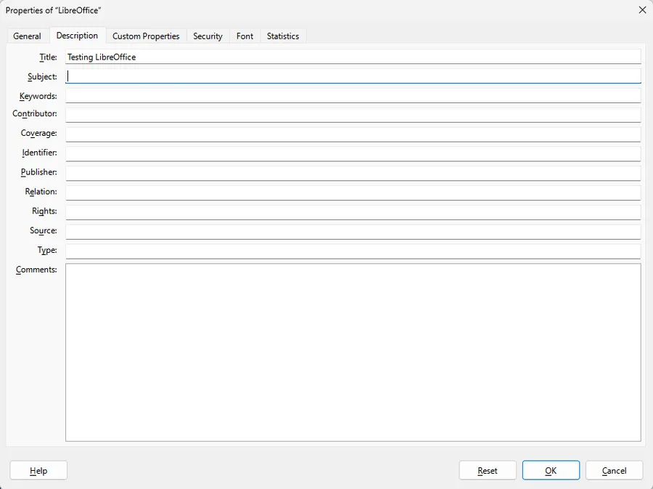

Copy the contents of the Title into the Subject field

Add applicable SEO keywords into Keywords field

Add Contributor

Add Publisher

https://www.makethingsaccessible.com/guides/creating-accessible-pdfs-from-libreoffice-writer/

9/36

30/07/2025, 01:17

Creating accessible PDFs from LibreOffice Writer | Make Things Accessible

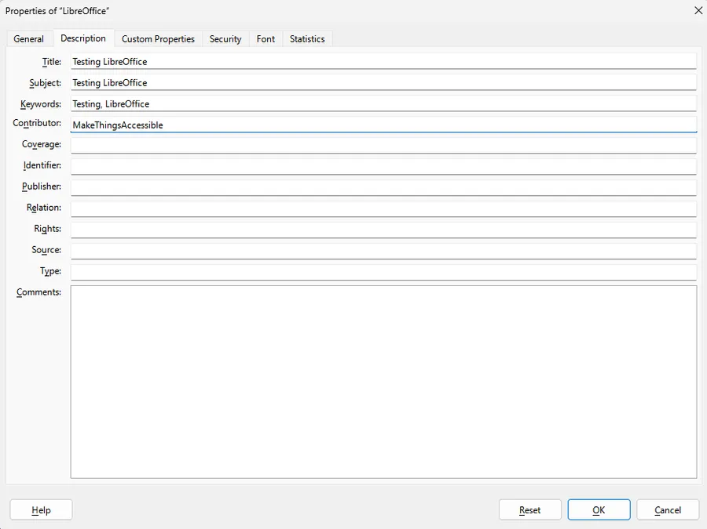

**Alt text**

The error reported is “Missing alternative or description text” because the images do not

have alt text set or are not marked as decorative.

Click on the



by “Image name”

https://www.makethingsaccessible.com/guides/creating-accessible-pdfs-from-libreoffice-writer/

10/36

30/07/2025, 01:17

Creating accessible PDFs from LibreOffice Writer | Make Things Accessible

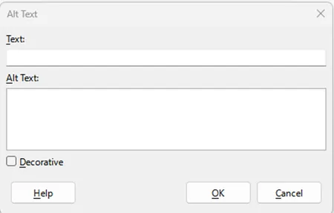

The fields are used as follows:

Text: used to enter a short description of the essential details of the selected

object, and is available to be used by assistive technologies

Alt Text: allows the entry of a longer description for objects that are too complex or

contain too much detail to be described adequately in the short Text field, and is

available to be used by assistive technologies

Decorative: marks the object as purely decorative and is ignored by assistive

technologies

The Text Alternative (Text), Description (Alt Text), and Decorative options are also

available by selecting the image, Right Click -> Properties, Options, Accessibility

https://www.makethingsaccessible.com/guides/creating-accessible-pdfs-from-libreoffice-writer/

11/36

30/07/2025, 01:17

Creating accessible PDFs from LibreOffice Writer | Make Things Accessible

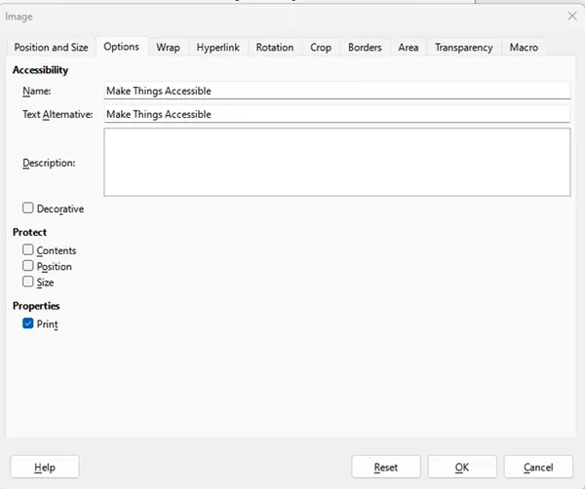

The exported PDF failed on the logo in the Header not having alt-text so make sure

that both Text Alternative and Description fields are filled

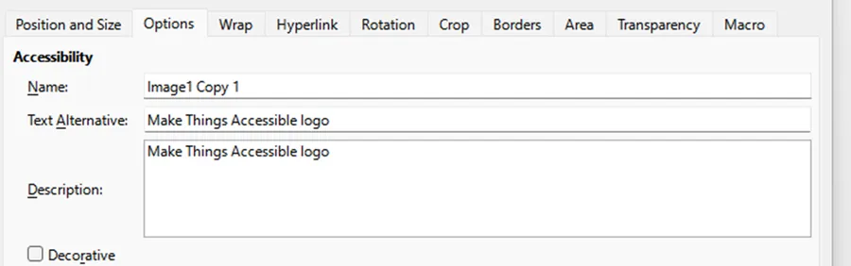

**Tables**

**Setting headings in tables**

**Inserting a table**

https://www.makethingsaccessible.com/guides/creating-accessible-pdfs-from-libreoffice-writer/

12/36

30/07/2025, 01:17

Creating accessible PDFs from LibreOffice Writer | Make Things Accessible

Table menu -> Insert Table

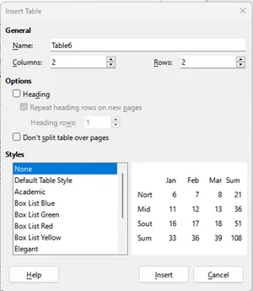

Insert table dialog box with column and row fields, options, including setting Heading,

and Repeat heading rows on new page as well as setting the table styles

Checking the Heading means that the top row cells are now styled as Table Heading

If the table is going to go more than one page, select “Repeat heading rows on new

pages” or select “Don’t split table over pages” to stop this from happening

**Editing a table**

Styles menu -> Manage Styles which brings up the Style pane

Select top row of cells and change Styles from “Table Contents” to “Table Heading”

**Repeating heading when table splits across**

**pages**

Right click on table and choose Table Properties, Text Flow tab and make sure that “Allow

the table to split across pages and columns”, “Allow row to break across pages and

columns”, and “Repeat heading” are checked

https://www.makethingsaccessible.com/guides/creating-accessible-pdfs-from-libreoffice-writer/

13/36

30/07/2025, 01:17

Creating accessible PDFs from LibreOffice Writer | Make Things Accessible

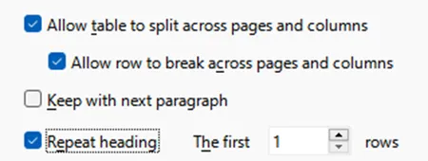

**Fixing errors**

**Table1” contains merges or splits**

The first error being reported is “Table: “Table1” contains merges or splits”

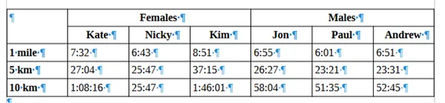

This problem can be sorted out by splitting the table into two tables, one for females

and one for males, and Table Heading added to columns and rows

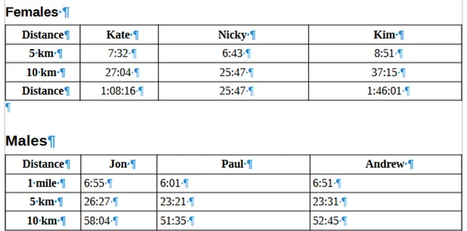

This problem can also be sorted out in the exported PDF using Adobe Acrobat Pro

https://www.makethingsaccessible.com/guides/creating-accessible-pdfs-from-libreoffice-writer/

14/36

30/07/2025, 01:17

Creating accessible PDFs from LibreOffice Writer | Make Things Accessible

**The text formatting conveys additional**

**meaning**

The second error being reported is “Formatting: The text formatting conveys additional

meaning”

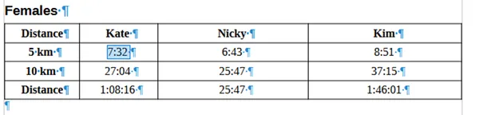

To fix this error, set the text to Body Text

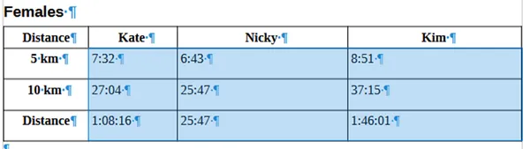

Then set the times back to the Table Contents style

**Avoid newlines to create space**

Make sure that “Formatting Marks” are visible by selecting View menu, Formatting

Marks (or Ctrl + F10)

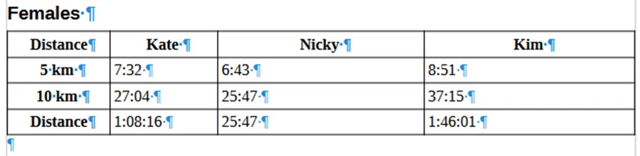

https://www.makethingsaccessible.com/guides/creating-accessible-pdfs-from-libreoffice-writer/

15/36

30/07/2025, 01:17

Creating accessible PDFs from LibreOffice Writer | Make Things Accessible

Delete the newline character after the table

To change space between the tables, open Table Properties, go to Table tab and

amend the Spacing Below

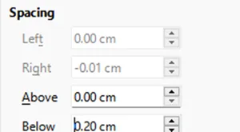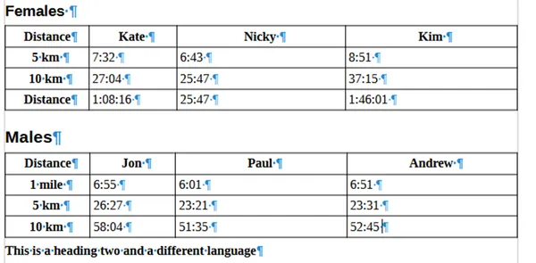

**Avoid using empty table cells for formatting**

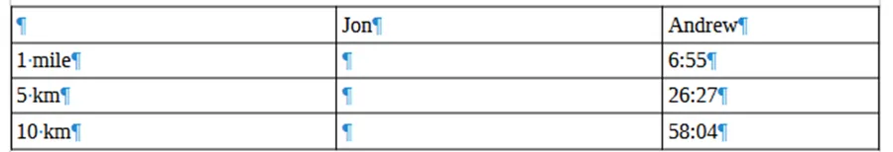

**Tables with empty cells**

There must never be blank heading cells so add an applicable title to the column

heading even if WCAG does allow for the first cell A1 to be blank (external

website)

https://www.makethingsaccessible.com/guides/creating-accessible-pdfs-from-libreoffice-writer/

16/36

30/07/2025, 01:17

Creating accessible PDFs from LibreOffice Writer | Make Things Accessible

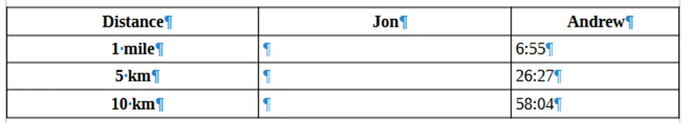

Different screen readers will announce empty cells in different ways (external

website) so the best solutions are to use “Not applicable” or “No value”

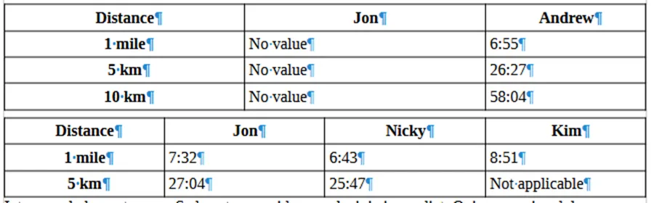

**Headings**

**The text formatting conveys additional**

**meaning**

The error reported is “Formatting: The text formatting conveys additional meaning”

because the potential headings are formatted using Bold rather than using Heading 1,

Heading 2 etc.

Select text to be used as heading and style as appropriate.

**“Outline levels of headings not in**

**sequential order” and “A heading with**

**outline level 4 must not follow a heading**

**with outline level 2”**

https://www.makethingsaccessible.com/guides/creating-accessible-pdfs-from-libreoffice-writer/

17/36

30/07/2025, 01:17

Creating accessible PDFs from LibreOffice Writer | Make Things Accessible

“Heading 4” is set to Heading 4, and the heading above is set to Heading 2, which means

that there is either a heading between them that has been set incorrectly or either

“Heading 2” or “Heading 4” are not set correctly. Correct the heading so they are now in

sequential order.

**Lists**

**Simulated numbering “1. 2….” when**

**headings are involved**

https://www.makethingsaccessible.com/guides/creating-accessible-pdfs-from-libreoffice-writer/

18/36

30/07/2025, 01:17

Creating accessible PDFs from LibreOffice Writer | Make Things Accessible

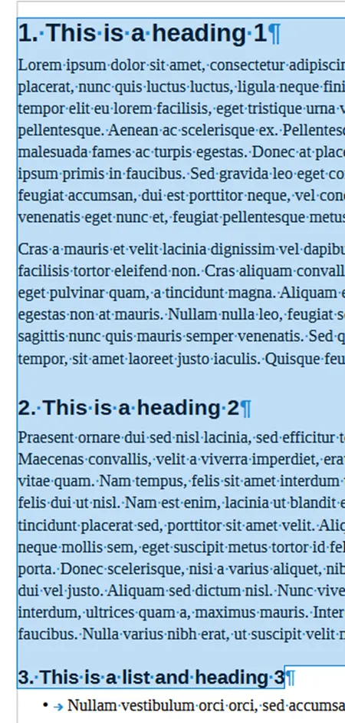

Delete the numbers

Set each heading to the same level as this is a list, they need to be the same

https://www.makethingsaccessible.com/guides/creating-accessible-pdfs-from-libreoffice-writer/

19/36

30/07/2025, 01:17

Creating accessible PDFs from LibreOffice Writer | Make Things Accessible

Select the text

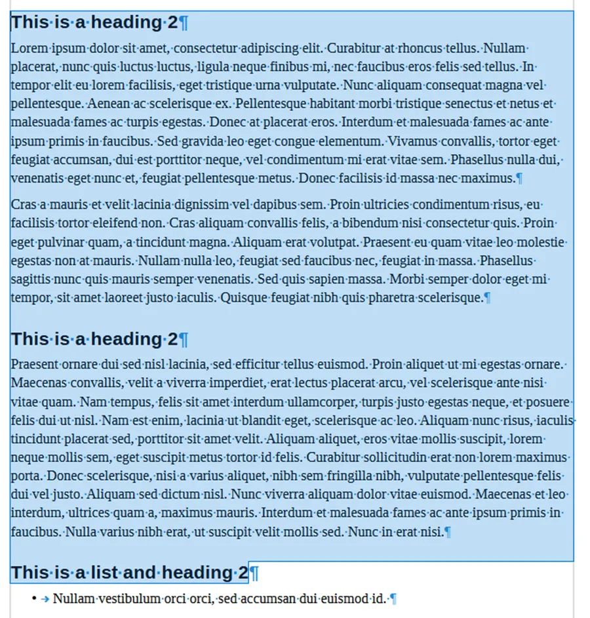

Select Tools menu and “Heading Numbering…”

https://www.makethingsaccessible.com/guides/creating-accessible-pdfs-from-libreoffice-writer/

20/36

30/07/2025, 01:17

Creating accessible PDFs from LibreOffice Writer | Make Things Accessible

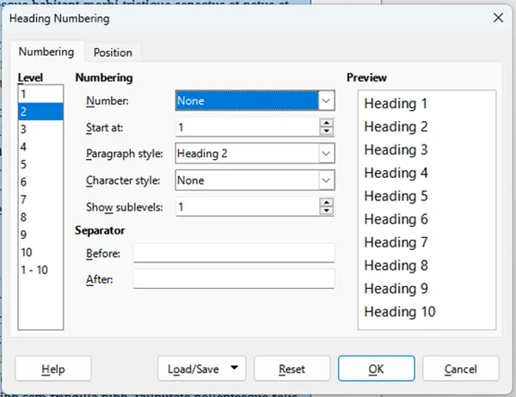

Change number to relevant styling

https://www.makethingsaccessible.com/guides/creating-accessible-pdfs-from-libreoffice-writer/

21/36

30/07/2025, 01:17

Creating accessible PDFs from LibreOffice Writer | Make Things Accessible

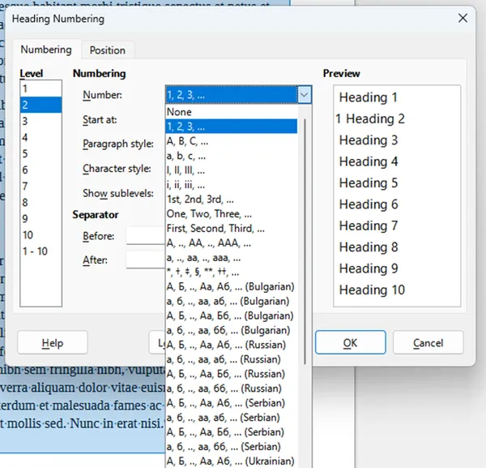

The headings will now be a properly created numbered list – this will apply to all

headings at (in this instance as shown in the Level field) level 2

https://www.makethingsaccessible.com/guides/creating-accessible-pdfs-from-libreoffice-writer/

22/36

30/07/2025, 01:17

Creating accessible PDFs from LibreOffice Writer | Make Things Accessible

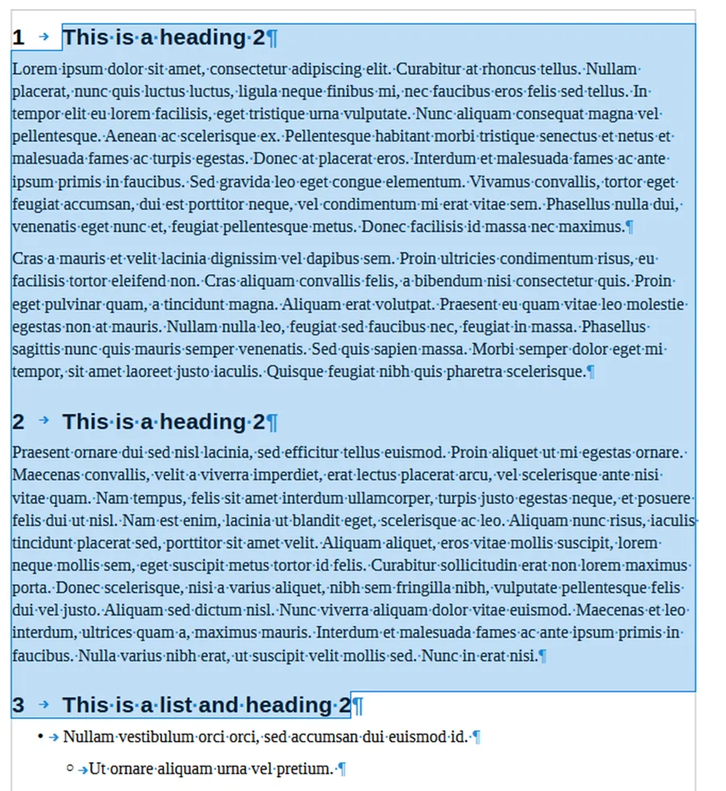

Numbered list of headings is removed in the fixed document and replaced with

appropriate Headings

**Simulated numbering “1. 2….” when it is**

**just a list**

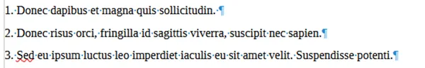

https://www.makethingsaccessible.com/guides/creating-accessible-pdfs-from-libreoffice-writer/

23/36

30/07/2025, 01:17

Creating accessible PDFs from LibreOffice Writer | Make Things Accessible

Delete numbers

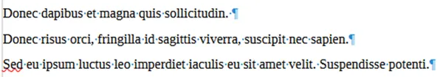

Select lines of text and use Ordered List button to create ordered list

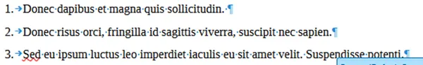

**Hyperlinks**

**Hyperlink text is the same as the link**

**address**



The link text is the full url

Right click and “Edit Hyperlink…”

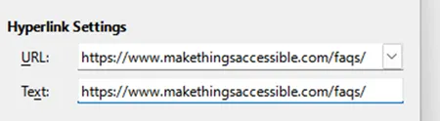

Change the Text field to be descriptive text

https://www.makethingsaccessible.com/guides/creating-accessible-pdfs-from-libreoffice-writer/

24/36

30/07/2025, 01:17

Creating accessible PDFs from LibreOffice Writer | Make Things Accessible

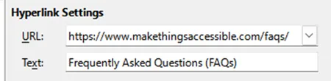

Adobe Acrobat will automatically make text that appears to be a hyperlink clickable as

a hyperlink without it being a proper hyperlink in the PDF document so text like below



Will be clickable in the exported PDF and should be made into a hyperlink in the

original document using good link text

Note: ScreenTips are not able to set unlike Microsoft Word

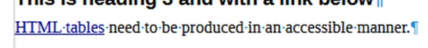

**Paragraphs**

**Text contrast is too low**

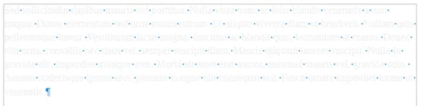

Select text and change the text colour

https://www.makethingsaccessible.com/guides/creating-accessible-pdfs-from-libreoffice-writer/

25/36

30/07/2025, 01:17

Creating accessible PDFs from LibreOffice Writer | Make Things Accessible

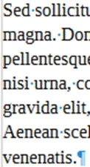

TPGi’s Colour Contrast Analyzer (external website) can be used to check the

contrast between the text colour and the background

**Avoid newlines to create space**

Make sure that “Formatting Marks” are visible by selecting View menu, Formatting

Marks (or Ctrl + F10)

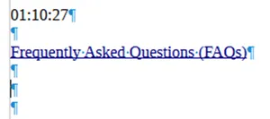

Delete unneeded newlines

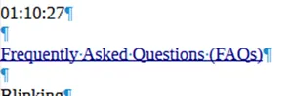

**The text formatting conveys additional**

**meaning**

https://www.makethingsaccessible.com/guides/creating-accessible-pdfs-from-libreoffice-writer/

26/36

30/07/2025, 01:17

Creating accessible PDFs from LibreOffice Writer | Make Things Accessible

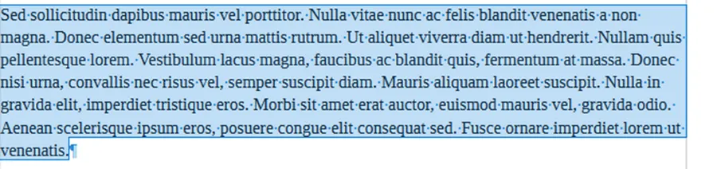

Select text and chose “Clear Formatting”

Set text to required style (in this case “Body Text”)

**Blinking text**

Select text and go to Styles menu and choose “Clear Formatting”.

**Footnotes and Endnotes**

Footnotes and Endnotes can be correctly defined and made accessible using Adobe

Acrobat Pro but to get the Accessibility Check to pass footnotes and end notes must be

put inline.

**Creating a table of contents or TOC**

Insert menu, Table of Contents and Index, Table of Contents, Index or Bibliography…

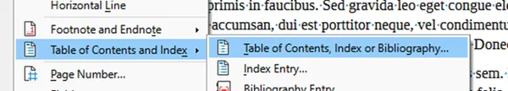

Gives you the options to automatically build TOC or create a customized TOC

https://www.makethingsaccessible.com/guides/creating-accessible-pdfs-from-libreoffice-writer/

27/36

30/07/2025, 01:17

Creating accessible PDFs from LibreOffice Writer | Make Things Accessible

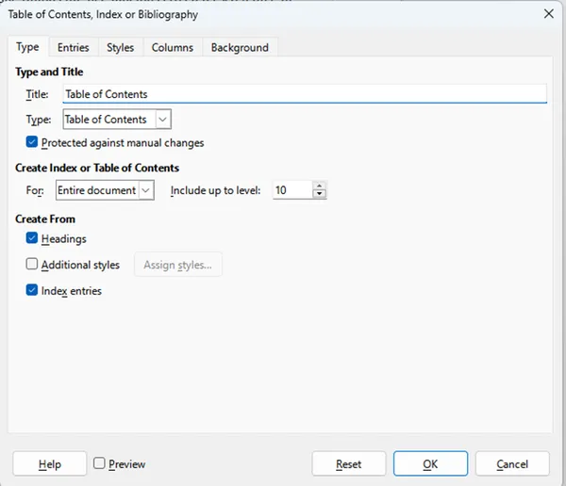

Because heading styles have been applied, Writer uses them to create TOC

**Artifacting objects**

Header and Footer objects are artifacted when exported to PDF.

**Exporting to a PDF**

File, Export As, Export As PDF

Remember to enable the Universal Accessibility (PDF/UA) option in PDF export and

Tagged PDF (add document structure) is also selected

https://www.makethingsaccessible.com/guides/creating-accessible-pdfs-from-libreoffice-writer/

28/36

30/07/2025, 01:17

Creating accessible PDFs from LibreOffice Writer | Make Things Accessible

**Check for accessibility in**

**Adobe Acrobat Pro PDF**

Note: to be able to remediate PDFs, Adobe Acrobat Pro or equivalent PDF editing

software is required.

“Walk” the Tag Tree by clicking on the first item in the tree, then using the down arrow

key (and right arrow key to open the tag where applicable, list etc.) so that the order

the PDF is read can be checked

In this case everything is good but if it is not, the tags will need to be rearranged into

the correct order

Click on “All tools” menu, “Prepare for accessibility” and choose “Check for

accessibility” and “Start Checking”

The document fails on “Tab order failed”, right click and “Fix” (hence order checked

before doing this)

**Check for accessibility in PAC**

**2024**

Open PAC 2024 and drag and drop the PDF file onto



The test will run and errors will be reported

https://www.makethingsaccessible.com/guides/creating-accessible-pdfs-from-libreoffice-writer/

29/36

30/07/2025, 01:17

Creating accessible PDFs from LibreOffice Writer | Make Things Accessible

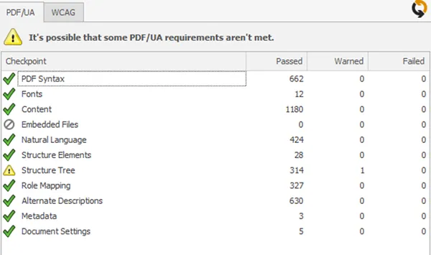

Click on “Results in Detail” button which opens up

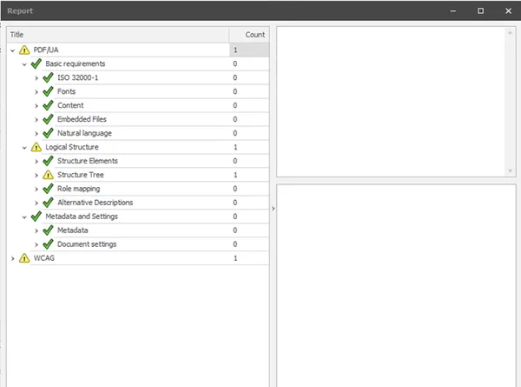

And drill down to the warnings

https://www.makethingsaccessible.com/guides/creating-accessible-pdfs-from-libreoffice-writer/

30/36

30/07/2025, 01:17

Creating accessible PDFs from LibreOffice Writer | Make Things Accessible

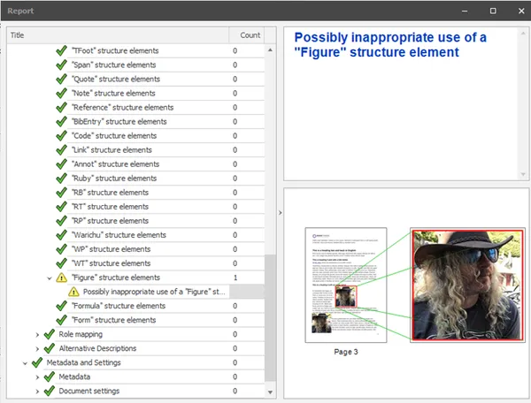

There are two warnings for ‘Possibly inappropriate use of a "Figure" structure element’,

one in Structure Tree and the other in WCAG 4.1.1 Parsing

**Fixing this issue**

Open file in Adobe Acrobat

Open Accessibility tags pane

Find page and select some text by the image, and then click on the “…” and “Find Tag

from Selection” so that the correct image can be found in the Accessibility tags pane

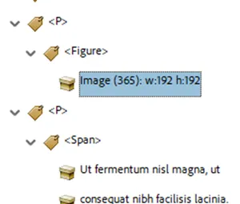

https://www.makethingsaccessible.com/guides/creating-accessible-pdfs-from-libreoffice-writer/

31/36

30/07/2025, 01:17

Creating accessible PDFs from LibreOffice Writer | Make Things Accessible

Right click

tag and choose Properties

<Figure>

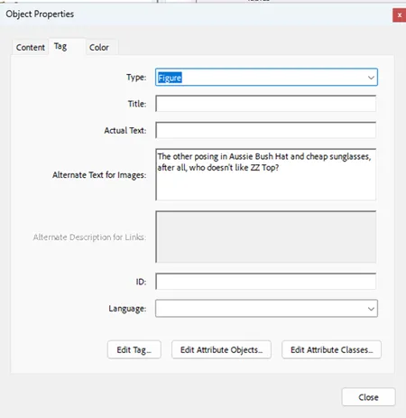

Select “Edit Tag…” button and then open up the first

object

<Dictionary>

https://www.makethingsaccessible.com/guides/creating-accessible-pdfs-from-libreoffice-writer/

32/36

30/07/2025, 01:17

Creating accessible PDFs from LibreOffice Writer | Make Things Accessible

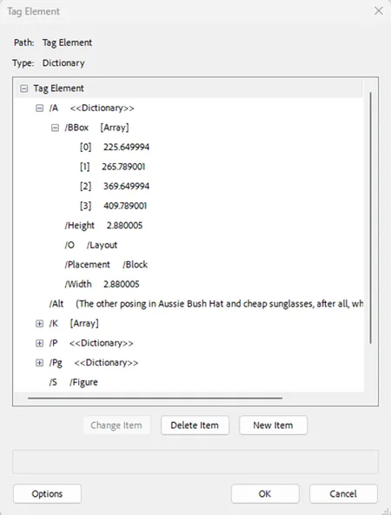

Find the Placement attribute and select it

Change from Block to Inline (sometimes it might need to be changed TO Block!)

Hit the



“The PDF/UA requirements checked by PAC are fulfilled.”

**Downloadable Microsoft Word**

**version**

https://www.makethingsaccessible.com/guides/creating-accessible-pdfs-from-libreoffice-writer/

33/36

30/07/2025, 01:17

Creating accessible PDFs from LibreOffice Writer | Make Things Accessible

Creating accessible PDFs from LibreOffice Writer (Word 1028KB)

**Useful links**

LibreOffice (external website)

PAC 2024 (external website)

TPGi’s Colour Contrast Analyzer (external website)

Writing for GOV.UK (external website)

Plain English Campaign (external website)

Hemingway Editor (external website)

WebFX Readability Test (external website)

Plain English – Advisory eLaHub (external website)

WCAG 3.15 Reading Level (AAA) (external website)

Accessible Document Basics

Creating meaningful alternative text

Alt Text in LibreOffice (external website)

Using Tables within LibreOffice Writer (external website)

Working with Tables in LibreOffice (external website)

How to handle blank data cells in accessible tables (external website)

Accessibility Check (external website)

Exporting to a PDF (external website)

Possibly inappropriate use of a "Figure" structure element when using PAC

2021 (external website)

Accessibility Checker and Accessibility Check (external website)

**Share on:**



https://www.makethingsaccessible.com/guides/creating-accessible-pdfs-from-libreoffice-writer/

34/36

30/07/2025, 01:17

Creating accessible PDFs from LibreOffice Writer | Make Things Accessible

**About Steve**

Westminster.

Eur Ing Stephen Wilkinson PGCert BSc(Hons) CEng MBCS CITP AdvancedRITTech

International Association of Accessibility Professionals (IAAP)

IAAP Certified Professional in Accessibility Core Competencies (CPACC)

DHS Trusted Tester

Pronouns: he/him

**Position:**

Senior Digital Accessibility Analyst

**Organisation:**

University of Westminster

/in/kneeboarder/



After 18 years working in local government as a SOCITM award winning webmaster and

developer, Steve is working as a Digital Accessibility specialist for the University of

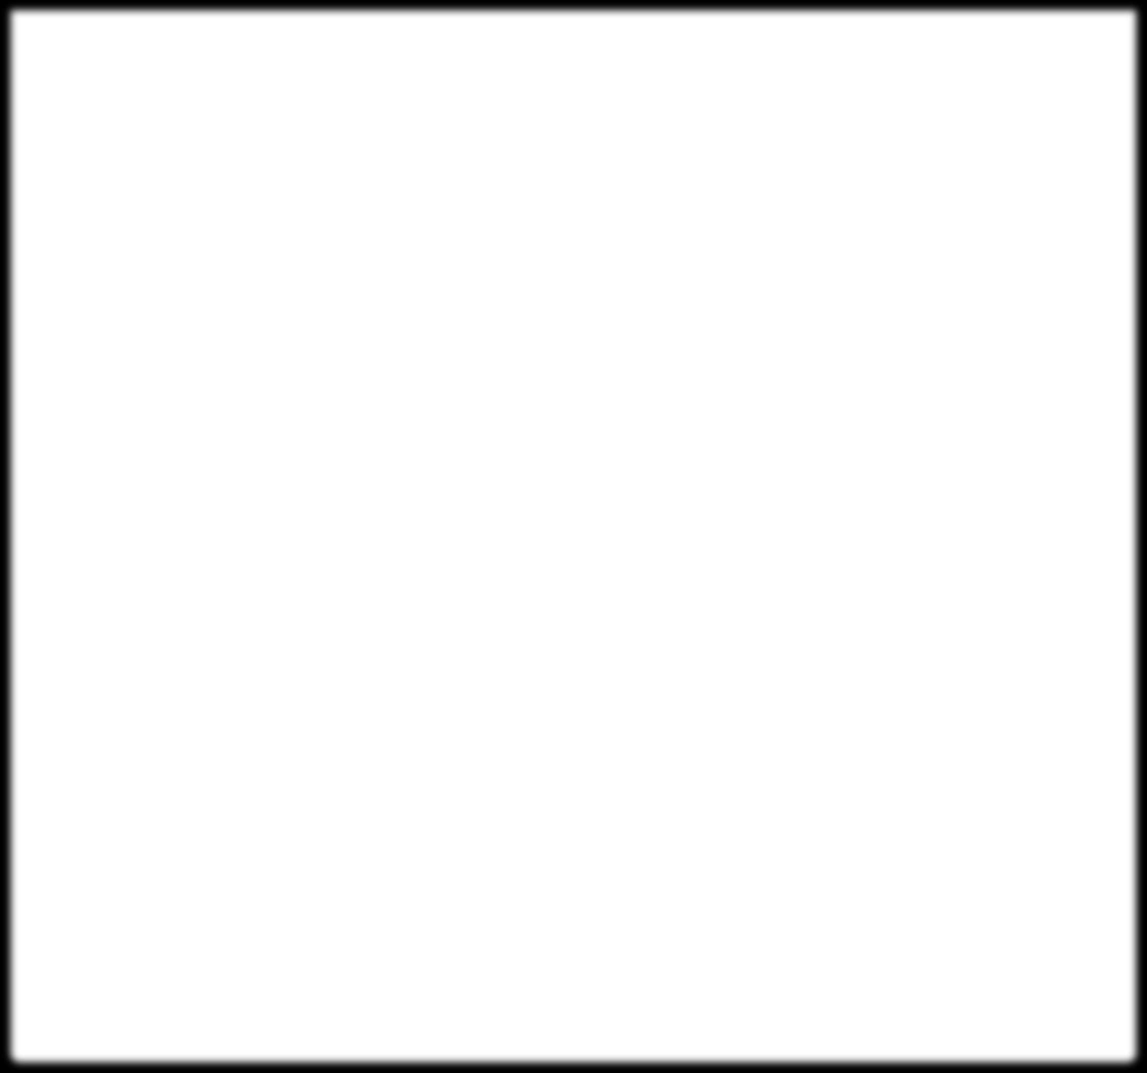

**Contact us**

info@makethingsaccessible.com

**Need help?**

If you have trouble with accessing any part of our site or links, please let us know and one

of our experienced team will identify and resolve the problem. If any part of the site does

https://www.makethingsaccessible.com/guides/creating-accessible-pdfs-from-libreoffice-writer/

35/36

30/07/2025, 01:17

Creating accessible PDFs from LibreOffice Writer | Make Things Accessible

not work as intended with your assistive technology, please provide details of the

browser, assistive technology you're using, and the URL wherever possible.

**Make Things Accessible links**

Home

About

Guides

FAQs

Accessibility

Glossary

Privacy Policy

Sitemap

Code of Conduct

Contributing

Admin

**RNIB**

Accessibility passport

**Access and Assistance for All**

AAA Home

AAA Roles

AAA Student Stories

AAA Supporters

© 2025 Make Things Accessible (v2.0) - powered by

Netlify

&

11ty

https://www.makethingsaccessible.com/guides/creating-accessible-pdfs-from-libreoffice-writer/

36/36